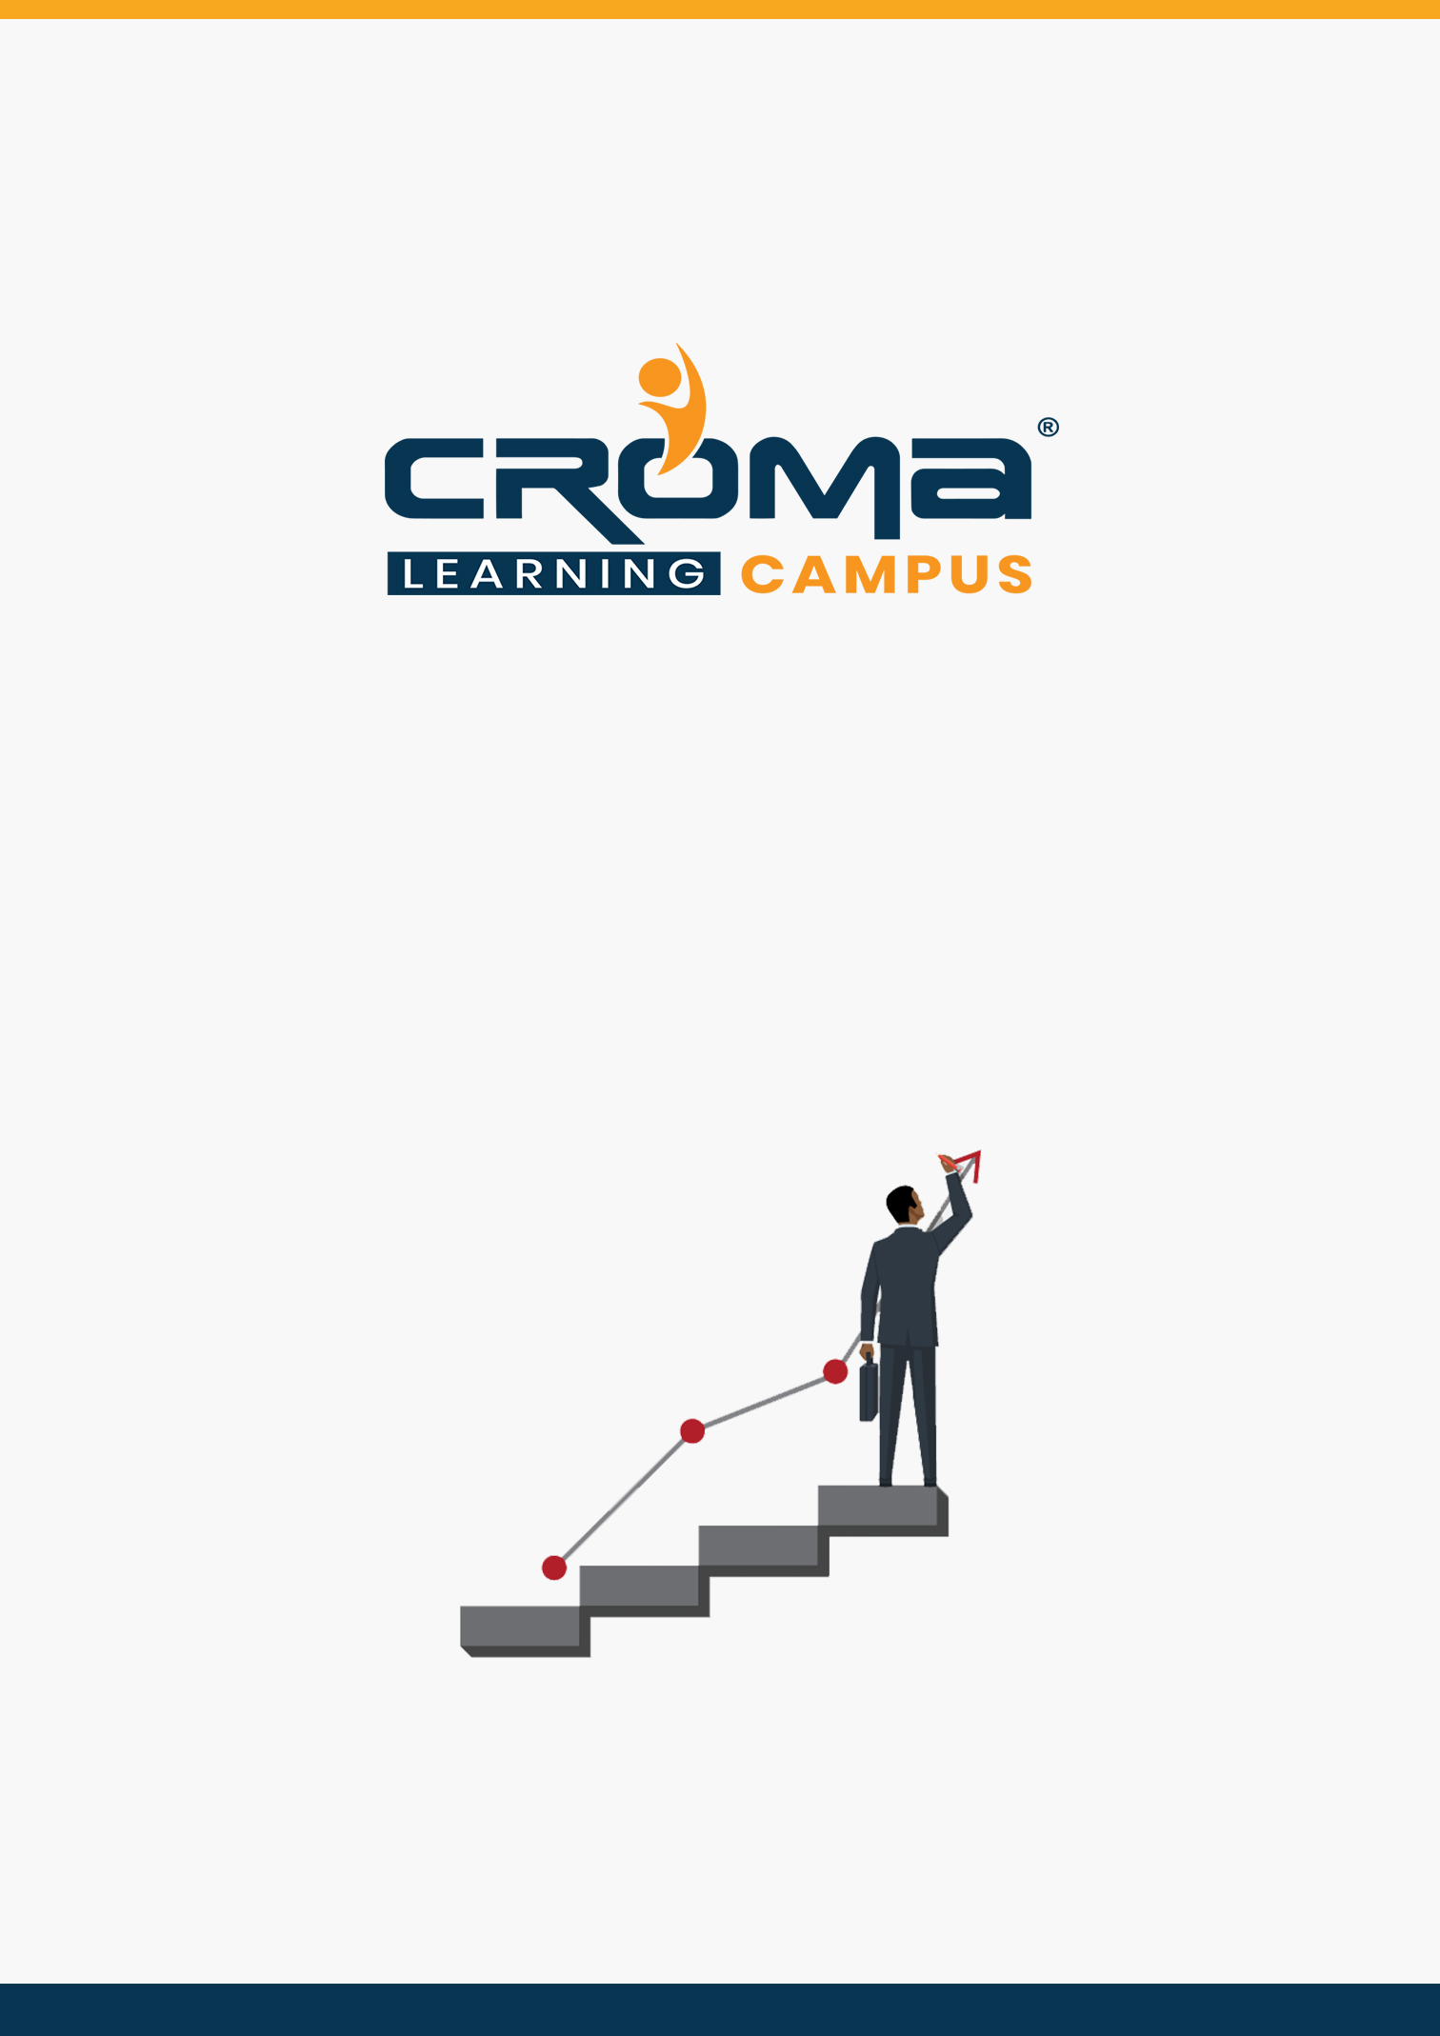

**Salesforce Lightning Web Components**

**Training Curriculum**

**STRUCTURE**

**www.cromacampus.com | helpdesk@cromacampus.com | +91-120-4155255**

**Salesforce Lightning Web Components Training Curriculum**

*“Give an edge to your career with comprehensive Salesforce Lightning web components Training Course at Croma Campus.”*

**About Croma Campus:**

Croma Campus Training & Development Private Limited is an education platform since 2010 providing rigorous industry-relevant programs designed and delivered in collaboration with world-class faculty and industry.

* Hands-On Live Projects
* Simulation Test Papers
* Industry Cases Studies
* 61,640+ Satisfied Learners
* 140+ Training Courses
* 100% Certification Passing Rate
* Live Instructor Classroom / Online Training
* 100% Placement Assistance

**Course Objectives:**

* Lightning apps on the app exchange.
* Lightning dashboards and reports.
* Lightning security.
* Lightning process builder.
* Custom app in lightning.
* Data import wizard.
* Click application development.

**Course Description:**

Salesforce Lightning will create a dynamic revolution in 2020 by tremendous developments and technology advancements. According to the recent survey conducted by top job portals, it is evident that there is a huge requirement for Salesforce admins and developers all over the world. Certified Salesforce administrators earn an average salary of $87,000 USD per annum. But, depending on their knowledge, skills, and experience their salary might increase up to $160,000.

This course develops your coding skill set to the next level. The lightning components provide an out-of-the-box set of components that allows building applications, event-driven architecture providing decoupling between components, and a framework optimized for performance by utilizing the server, browser, network, and devices.

Enroll in this course to gain programming experience using Lightning Components, JavaScript, CSS, Apex, and the Salesforce Lightning Design System (SLDS), and deploy them successfully for use by Salesforce end users.

**Croma Campus Training Program Deliverables:**

* **Session Recordings** - Original Class Room Voice & Video Recording
* **Training Material** - Soft Copy Handbooks
* **Assignments** | 25+ Hands-on Exercises
* **Test Papers** - We provide **Practice Test** as part of our course to help you prepare for the actual certification exam.
* **Live Case Studies**
* **Live Projects** - Hands-on exercises and Project work. You will work on real time industry-oriented projects and assignments for each module to practice.
* **Key focus on Hands-on exercises and Project work**. You will work on real time industry-oriented projects.
* Faculty with more than **10+ Years of Experience** in the Industry.
* **Technical Resume Designing & Job Assistance:** With more than 100+ Clients across the Globe and we help learners to get a good job in their respective field. We also help learners with resume preparation.
* **Interview Q&A**
* **About Croma Campus Training Certificate:** Croma Campus will provide you with an industry-recognized (Certified by **ISO 9001:2015** & **E-Cell IIT Jodhpur**) course completion certificate which has lifelong validity.
* **How I Unlock my Croma Campus Certificate:** Attend Complete Batch & Submit at least One Completed Project.

**Course Content:**

* **LWC vs Aura Components**

In the first lecture, we will try to understand the Architecture of **Lightning Web components** and **Lightning Aura components.** And Why Salesforce has gone for new Programming model (LWC) on Lightning platform and how it is different from existing aura framework.

* **System Setup**

System setup involves Installing Salesforce CLI, SFDX, and visual studio, Creation of Developer Org, Scratch Org etc.,

* **First LWC Component**

How to Create and deploy a simple HelloWorld Lightning Web component?

* **Component Bundle**

Archetype of LWC, Project / Component Structure

* **Decorators**

Introduction to decorators, Adaptors, Reactive and non-reactive properties

* @api
* @track
* @wire
* **Work with Salesforce Data**

We will try to understand, how to call an apex class from lightning web component and dump data into JavaScript class

* Decorate to property
* Decorate to a function
* Imperative call
* **Lightning Data Service**

We will try to understand how we LDS can help us to Manipulate Salesforce records without the consent of Apex controllers

* Record Create form
* Record Edit from
* Record View Form
* **Modern JavaScript Series**

Having understood the basics of LWC, in order to take ourselves to the next level, we will be having a series of 3-4 lectures Modern JavaScript. So that Understanding the Advanced Concepts like Event Handling, Publish-Subscribe Pattern will be easier.

* Arrays in ES6
* Shadow DOM
* Promise Objects
* Event Handling
* Capturing and Bubbling
* **Composition**

Communication among components

* Parent to Child
* Child to Parent
* **Publish Subscribe pattern**

Sibling components communication will be discussed here

* **Lifecycle Hooks**

Component lifecycle hooks will be discussed in this unit

* constructor
* update public properties
* connected call back
* rendered call back
* disconnected call back
* error call back
* **Static Resources in LWC**

Importing 3rd party libraries into LWC

* **Lightning/UI*API Module**

Standard libraries of front end controller based on User Interface API will be discussed

* **Lightning Navigation Module**
* Navigation mix-in
* CurrentPageReference
* **@Salesforce Module**
* @salesforce/apex
* @salesforce/contentAssetsUrl
* @salesforce/i18n
* @salesforce/label
* @salesforce/resourceUrl
* @salesforce/schema
* @salesforce/user
* **Debugging LWC**
* Enable debug mode
* chrome dev tools
* **Introduction to Jest framework**

Debugging and Testing LWC. Introduction to jest framework.

**Install**

* Node.js
* lwc-jest module
* **Write the first test class**
* **Jest framework matchers**

When you’re writing tests, you often need to check that values meet certain conditions. expect gives you access to a number of “matchers” that let you validate different things.

* **Sample Projects**

We will try to understand all the above concepts that we have learnt through the official sample projects launched by Salesforce on LWC.

* lwc Recipes
* ebikes – retail / e-commerce
* Dream house – real Estate
* **Placement Guide**
* Tips to clear an Interview
* Common Interview questions and answers
* Salesforce Lightning Interview Questions and Answers
* Resume Building Guide
* Career roadmap and certifications
* Attempt for the related Global Certification Exam
* Start applying for Jobs